**Task 20: EBS LIFECYCLE**

AWS EBS:

Amazon Elastic Block Store (EBS) is a scalable and high-performance block storage service for Amazon EC2 instances. It provides persistent storage, meaning data remains intact even when the associated EC2 instance is stopped or terminated.

Benefits of AWS EBS:

* Durability and Persistence: Data stored on EBS persists independently of the EC2 instance lifecycle.
* Scalability: Allows easy resizing to accommodate increased storage needs.
* Performance: Offers SSD and HDD options to match workload performance requirements, with high IOPS for demanding applications.
* Backup and Restore: Snapshots can be taken for backup, replication, and recovery purposes.
* Flexibility: Volumes can be detached and reattached to different instances, providing flexibility in resource management.

Limitations of AWS EBS:

* Region-Specific: EBS volumes are confined to a single AWS region, which can limit multi-region deployments.
* Not Ideal for Cold Storage: EBS is more costly compared to other AWS storage options (e.g., S3) for rarely accessed data.
* Instance Dependency: EBS volumes require EC2 instances to be useful, as they are not standalone storage like S3.
* Scaling Limitations: While volumes can be resized, they can't be decreased in size once expanded.

1. Created an EC2 Instance

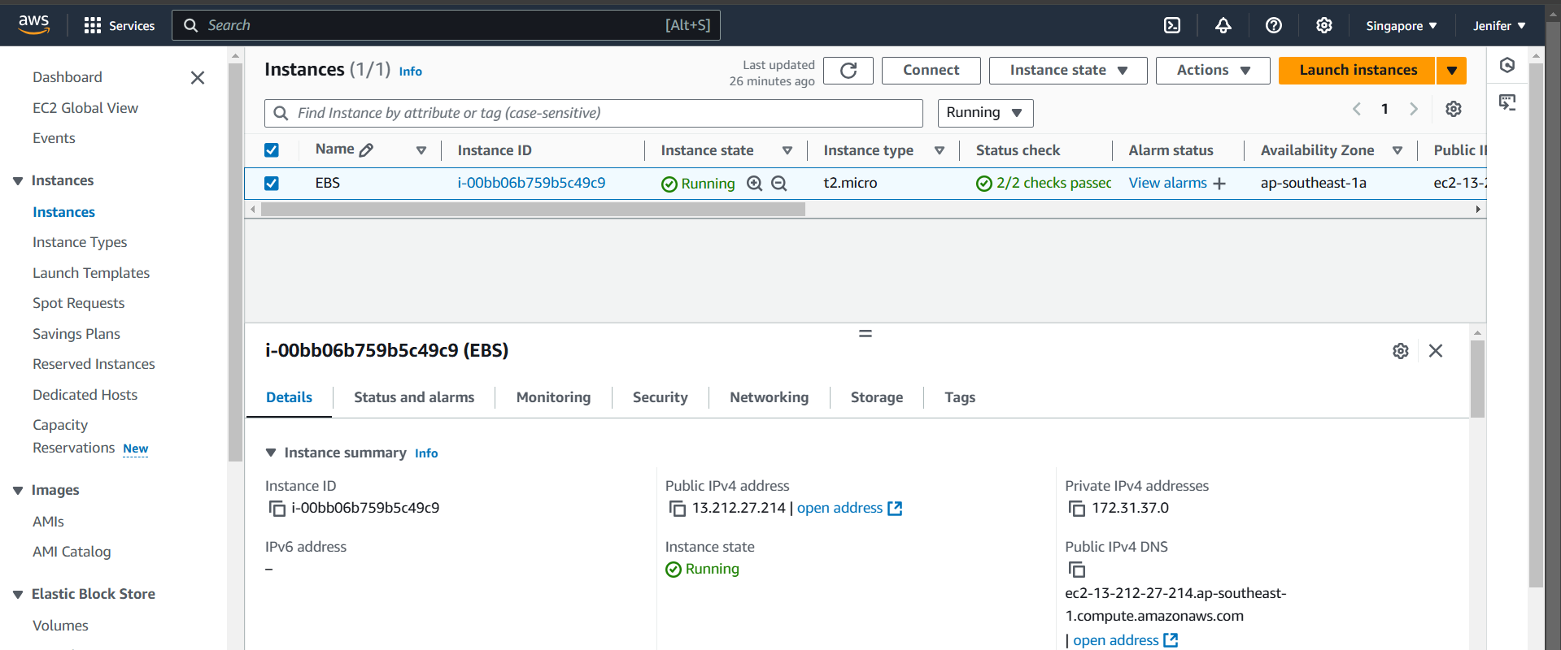

1. Created a new EBS volume for the created Instance

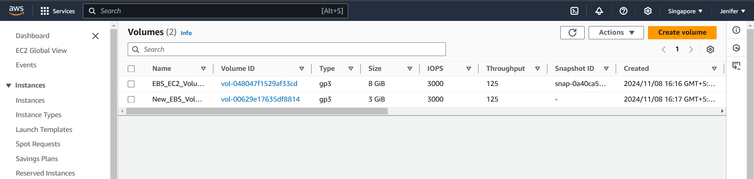

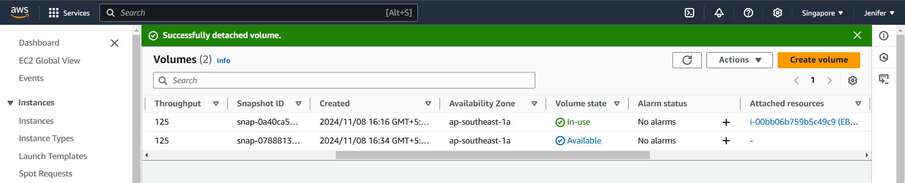

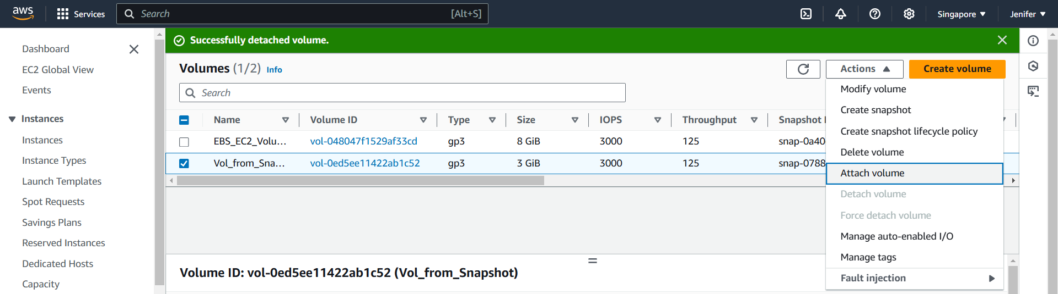

1. Attached the Volume to the Instance

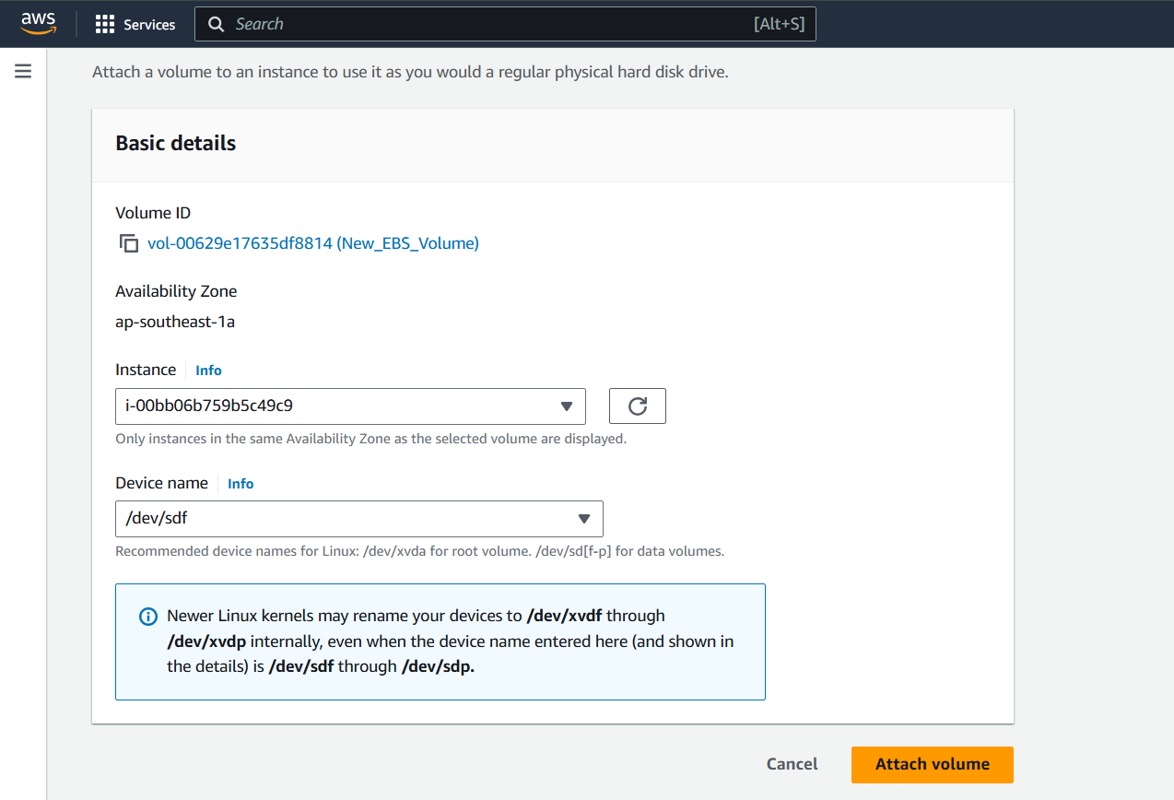

1. Logged into the Server, have mounted the Volume & Created a file name jendata

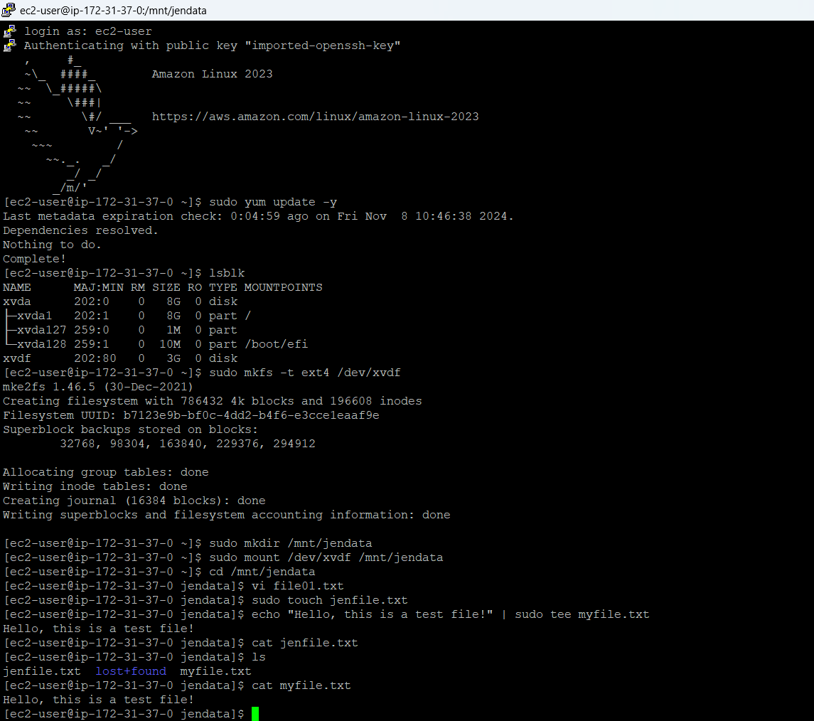

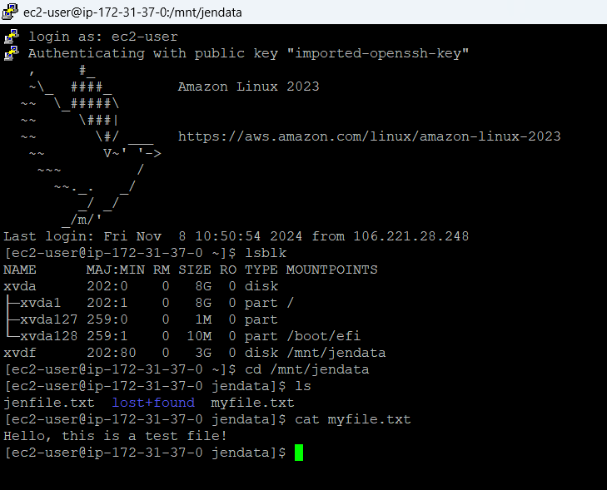

1. Logged out the server, detached the Volume from the server

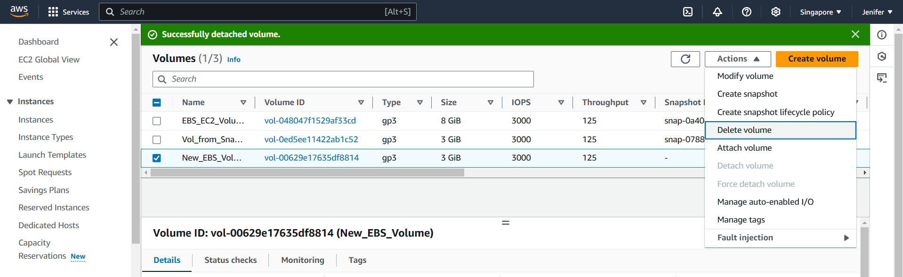

1. Snapshot created from the Volume

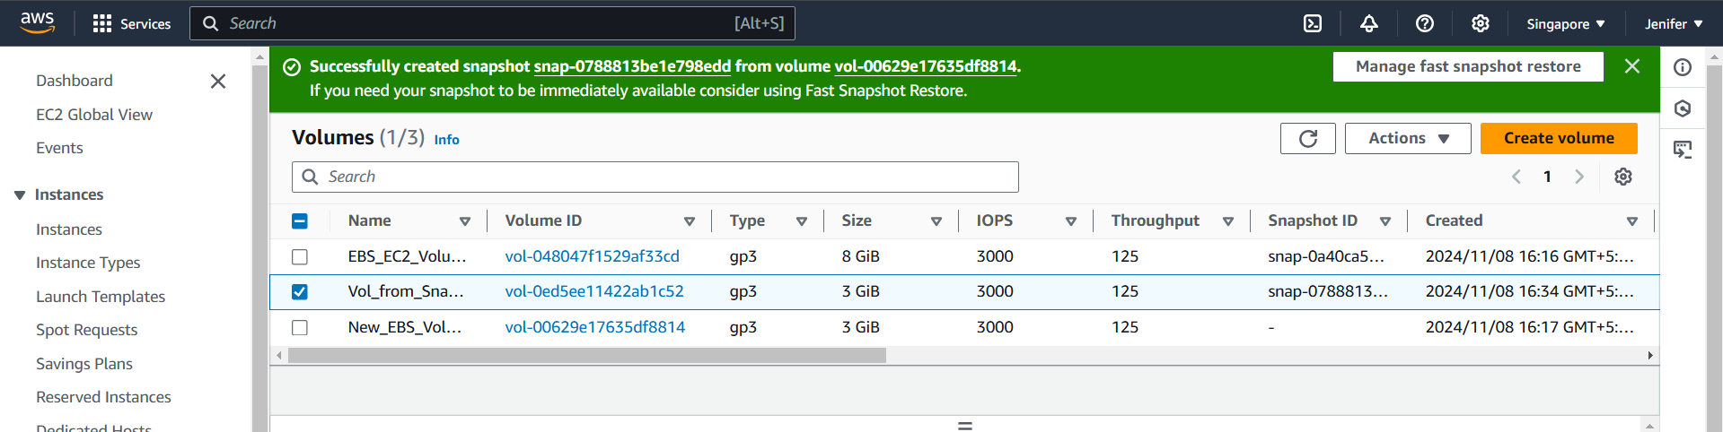

1. A new Volume created form the Snapshot

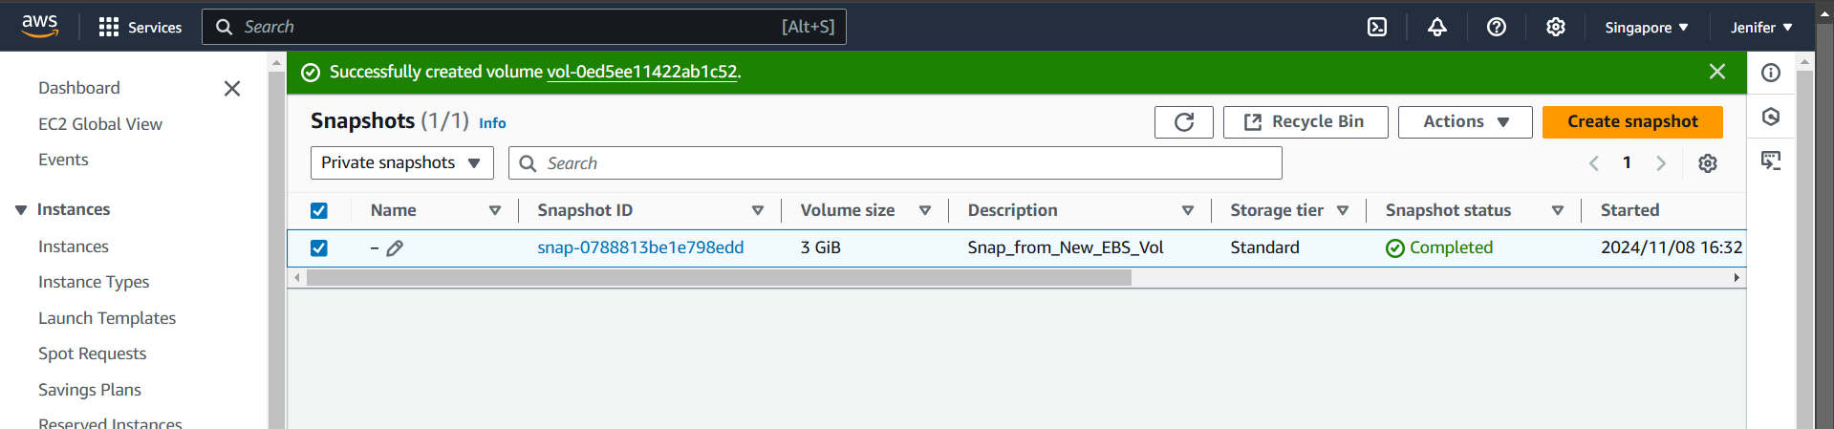

1. Before mount the new volume which is created from the snapshot

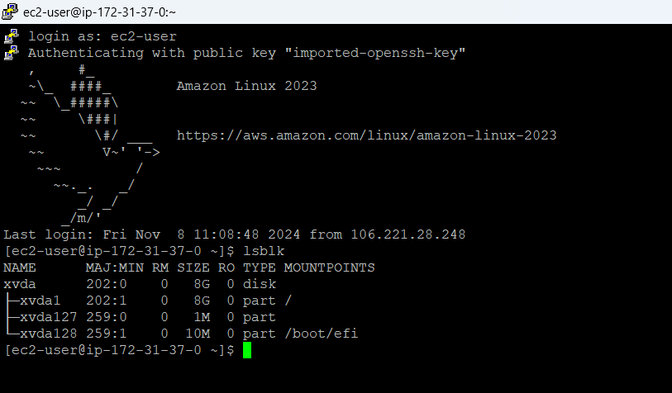

1. New Volume(created from the snapshot) attached to the Instance

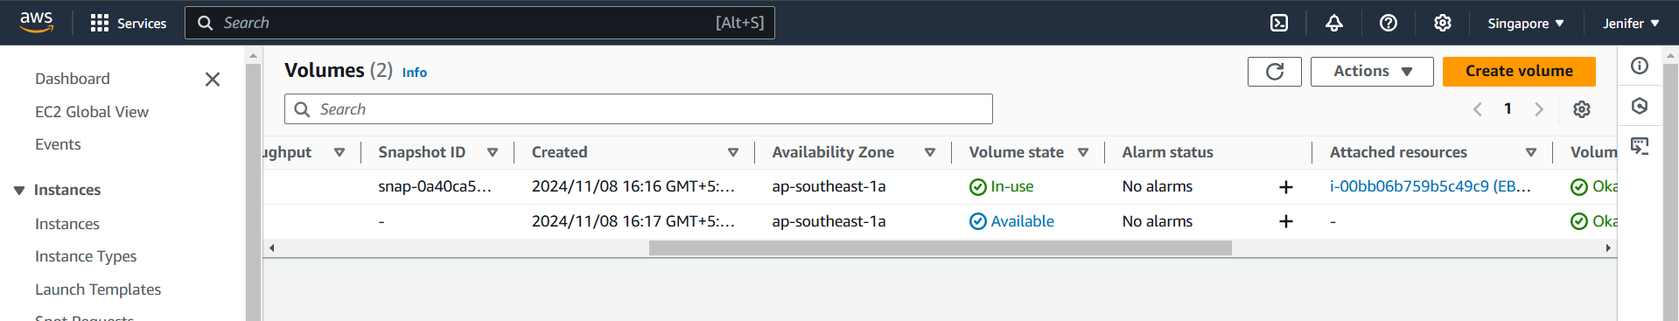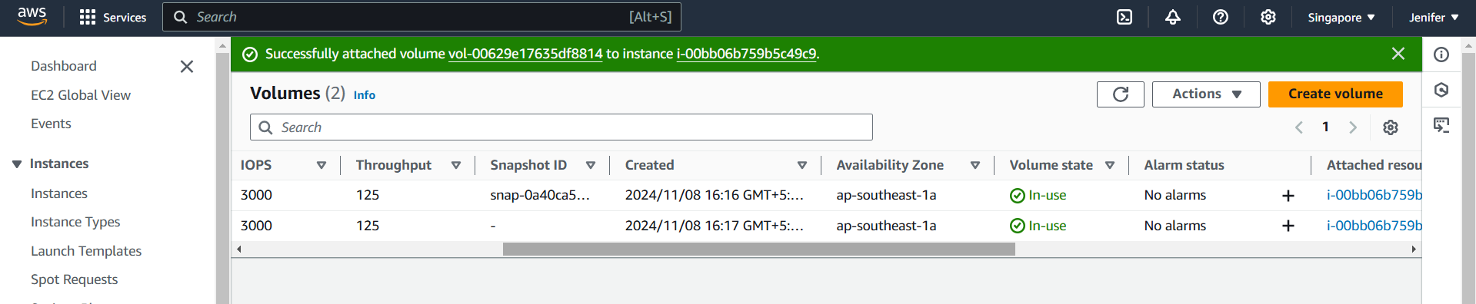

1. After Attaching the new volume to the Instance the file which I have created in the previous volume got reflected in the new volume as well

